8.74: Collision: Momentum conservation gives

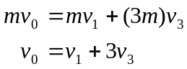 (1)
Energy Conservation:

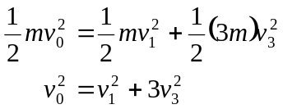 (2)

Solve (1) and (2) for 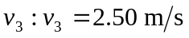
Energy conservation after collision:

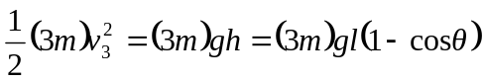

Solve for 